1.GIT – HOL

Git Configuration

Commands used:
git config --global user.name "Subalakshmi P"
git config --global user.email "22csecs.subalakshmi.p@skct.edu.in"

Output (example):

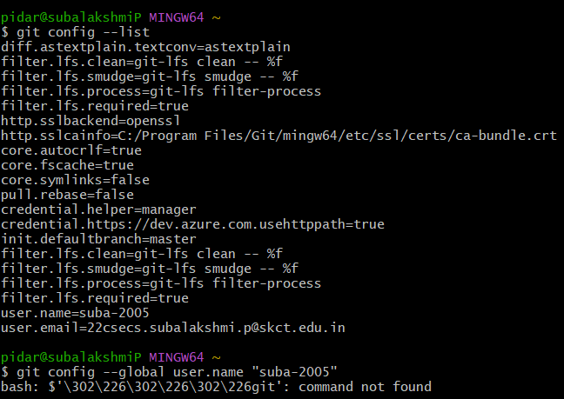

Integrating Notepad++

Steps:
- Locate Notepad++ (e.g., C:\Program Files\Notepad++)
- Add to PATH via:
  - Control Panel → System → Advanced system settings → Environment Variables
  - Edit "Path" under User Variables → Add Notepad++ path
- Set as default Git editor: git config --global core.editor "notepad++"
- Verify: git config --global -e

6. Create Local Repository
mkdir GitDemo
cd GitDemo
git init

7. Add File to Repository
echo "Welcome to GitLab hands-on session" > welcome.txt
git add welcome.txt
git commit -m "Initial commit: Added Welcome.txt"

8. Verify Commit

git log

OUTPUT
2. GIT – HOL

1. Create a remote GitLab repository (if not already done)
- Go to https://gitlab.com/
- Click ➕ New Project
- Name it: GitDemo
- Visibility: Private or Public (your choice)
- Click Create Project

2. Copy the HTTPS clone URL
https://gitlab.com/your-username/GitDemo.git

3. Link your local repo to GitLab
git remote add origin https://gitlab.com/your-username/GitDemo.git
(Replace the URL with your actual GitLab repo link)

4. Push your code to GitLab
If this is your first push, use:
git push -u origin master
(If your default branch is main on GitLab, replace master with main)
OUTPUT
3.GIT – HOL

PART 1: Branching in Git

Step 1: Create and switch to a new branch
git checkout -b GitNewBranch

Step 2: List all branches
git branch -a

Step 3: Add a file and write content
echo "This is a test file in GitNewBranch" > newfile.txt

Step 4: Stage the file
git add newfile.txt

Step 5: Commit the changes
git commit -m "Added newfile.txt in GitNewBranch"

Step 6: Check status
git status

PART 2: Merging in Git

Step 1: Switch to master
git checkout master

Step 2: Show CLI differences
git diff master GitNewBranch

Step 3: Visual difference using P4Merge
git difftool master GitNewBranch
P4Merge opens and shows visual diff.

Step 4: Merge GitNewBranch into master
git merge GitNewBranch

Step 5: Visualize merge history
git log --oneline --graph --decorate

Step 6: Delete the merged branch
git branch -d GitNewBranch

PART 3: Using GitLab for Branch and Merge Requests

Create a Branch in GitLab:
- Go to your GitLab project → Repository → Branches
- Click on New branch
- Name it GitNewBranch, and base it off main
- Click Create branch

Push your local branch to GitLab:
git push origin GitNewBranch
OUTPUT
4.GIT – HOL

Step 1: Initialize a Git repository (if not already done)
mkdir GitLabConflictDemo
cd GitLabConflictDemo
git init

Step 2: Create a base file and make an initial commit on master
echo "Initial setup" > setup.txt
git add setup.txt
git commit -m "Initial commit on master with setup.txt"

Step 3: Create a new branch GitWork and switch to it
git checkout -b GitWork

Step 4: Create hello.xml and add content in GitWork
echo "<message>Hello from GitWork</message>" > hello.xml
git add hello.xml
git commit -m "Added hello.xml in GitWork"

Step 5: Switch back to master
git checkout master

Step 6: Create a different version of hello.xml in master
echo "<message>Hello from master branch</message>" > hello.xml
git add hello.xml
git commit -m "Added hello.xml in master"

Step 7: View log history of both branches
git log --oneline --graph --decorate --all

Step 8: Check differences via CLI
git diff GitWork master

Step 9: View differences visually using P4Merge
git difftool GitWork master

Step 10: Merge GitWork into master
git merge GitWork

Step 11: Observe the conflict markers in hello.xml
cat hello.xml

Step 12: Resolve conflict using 3-way merge tool (P4Merge)
git mergetool

Step 13: Add and commit the resolved file
git add hello.xml
git commit -m "Resolved merge conflict in hello.xml"

Step 14: Add .orig backup file pattern to .gitignore
echo "*.orig" >> .gitignore
git add .gitignore
git commit -m "Ignore merge backup files"

Step 15: List all branches

git branch

Step 16: Delete the merged branch
git branch -d GitWork

Step 17: View final log history
git log --oneline --graph --decorate

OUTPUT

5. GIT – HOL

Step 1: Create a new Git project folder and initialize Git
mkdir GitPushDemo
cd GitPushDemo
git init

Step 2: Create and commit a sample file
echo "This is from Git-T03-HOL_002" > lab_notes.txt
git add lab_notes.txt
git commit -m "Added lab_notes.txt as part of Git-T03-HOL_002"

Step 3: Create a new repository on GitHub
- Go to https://github.com
- Click New repository
- Enter repository name: GitPushDemo
- Choose public or private
- Do not initialize with README
- Click Create repository

Step 4: Link local repo with remote GitHub repo
Replace <your-username> with your GitHub username:
git remote add origin https://github.com/<your-username>/GitPushDemo.git

Step 5: Verify if master is in clean state
git status

Step 6: List available branches
git branch -a

Step 7: Pull from remote (first time repo might not have content)
git pull origin master

Step 8: Push local commits to remote GitHub repo
git push -u origin master

Step 9: Verify the changes in the remote repo
- Go to https://github.com/<your-username>/GitPushDemo
- You should see:
  - lab_notes.txt
  - Your commit message: “Added lab_notes.txt as part of Git-T03-HOL_002”
OUTPUT

